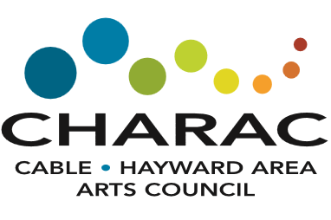

A Toast to Art – Holiday Style
An Online Silent Auction
November 1-14, 2020
Silent Auction Donation Information
Donor Name:
Email:
Phone:
Donation Description/Title:
Value:
Since this is an online auction, we must receive your donation no later than October 15th to allow time to prepare the auction.

Please email form to CHARAC at cablehaywardarts@yahoo.com or bring to Gallery & Gifts, 10529 Dakota Ave, Hayward with your donation.

