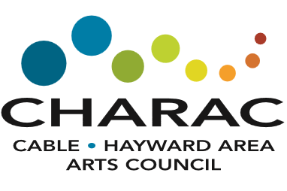
2021 CHARAC ART CRAWL PaRTICIPANT Application
August 13, 14, and 15th
Submit a separate application for each artist at a site
Deadline: March 20, 2021
Artist Information
Artist Name:
Host Name: |  |  |  | Host Phone #:
NO MORE THAN 4 ARTISTS AT A SITE
Artist Mailing Address | Street:
City: |  | State: |  |  |  | Zip:
Site Address | Street:
City: |  | State: |  |  |  | Zip:
Is this a home studio or business location?
If a business location, please provide contact info for business owner:
Closest major highway or intersection (ex: Hwy 63S, Hwy 27 N, etc.):
Is the location handicap accessible?
Artist phone #: |  |  | Artist Email Address:
Business Name (if applicable): |  |  | Website (if applicable):
Mediums:
Description (15 words or less):
Please indicate the number of brochures you would like for distribution: |  |  |  |  | Posters?
Please contact Carol Morness with questions regarding this application, brochure planning and/or implementation at studio.
Phone: 612-240-3477
Email: cbm0301@gmail.com
Mailing Address: CHARAC Art Crawl, PO Box 182, Cable, WI 54821
Submissions must be received no later than March 20, 2021.
*Completed Application (email or snail mail)
*3 high quality digital images of your artwork (500 KB or larger). Email or send via mail on a thumb drive.
*Artist fee: $100 for individuals who are CHARAC members in good standing; $130 for nonactive members. These fees may be paid on our website or mailed to CHARAC.
Please note that by submitting this application, you are agreeing to the following:
*Images and artist information may be used for promotional purposes.
*Each site is responsible for their own liability insurance.
*Artists are responsible for proof-reading their brochure information and provide signoff when received.
*Artists are responsible for displaying signage at their site, including picking up and returning to the designated location.
*Artists agree to be open during the entire crawl – Friday: 10-5; Saturday: 10-5; Sunday: 11-3
*Artists agree to aid in promotion of the Art Crawl by distributing posters and brochures in their surrounding area.
*Artists agree to collect attendance data during the Crawl dates and submit daily

