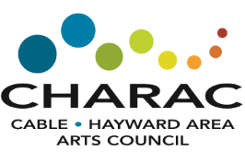
CHARAC Membership Form
O New O Renewal
Name(s):
Mailing Address:
Phone #: | Email Address:
And we would love to learn more about you!
O Art Supporter
Or
O Artist: My medium(s) is: ________________________________
How would you like to receive communications from CHARAC?
O Email Only
O USPS Only
O Both Email and USPS
Membership Levels
O $500 Benefactor
O $300 Patron Gold
O $200 Patron Silver
O $100 Patron Bronze
O $75 Business
O $50 Nonprofit/Schools
O $50 Household
O $30 Individual
O $20 Student
Remember-
All Artists with membership in good standing will have an Artist page on our website. This gives you the ability to upload your bio and photos for all visiting the website to see!
Return this form with check to CHARAC, P.O. Box 182, Cable, WI 54821

