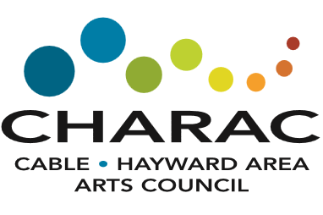
Application

Scholarship for the Arts
Offered to students beginning their higher education.

Submission Deadline: April 14, 2024
Applicant Name: |  |  |  |  |  |  | Date of Birth:
Home Mailing Address | Street:
City, State, Zip Code:
Phone #: |  |  |  |  | Personal email:
High School:
High School Counselor:
High School GPA:
School you may attend in Fall 2024. (name, city, state):
Have you been accepted? |  |  | Yes |  | Conditional |  |  | Not Yet
Will you be a full-time student? |  |  | Yes |  | No
Your Art Category |  |  | Visual Arts |  | Performing Arts |  | Literary Arts |  |  | Other
Feel free to attach an additional description page if needed
Formal and informal arts training, classes, workshops, internships, etc.

Activities, exhibitions, performances, recitals, etc.

How did your arts training and activities lead you to your course of study?

Describe your anticipated course of study.

Please also include a letter of recommendation
Please email completed application to: cablehaywardarts@yahoo.com or mail to
CHARAC, P.O. Box 1012, Hayward, WI 54843

