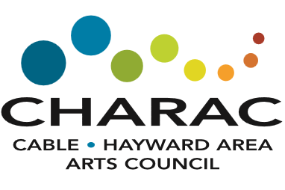
2025 Scholarship Application
Offered to students beginning their higher education with emphasis in the Arts.

Submission Deadline: April 14, 2025
Applicant Name: |  |  |  |  |  |  |  |  |  |  |  |  |  |  | Date of Birth:
Home Mailing Address |  |  |  |  | Street:
City, State, Zip Code:
Phone #: |  |  |  |  |  |  |  |  |  |  | Personal email:
High School:
High School Counselor:
High School GPA:
School you may attend in Fall 2025 (name, city, state):
Have you been accepted? |  |  |  |  |  |  |  | Yes |  |  | Conditional |  |  |  |  | Not Yet
Will you be a full-time student? |  |  |  |  |  |  |  | Yes |  |  | No
Your Art Category |  |  |  |  |  | Visual Arts |  | Performing Arts |  |  | Culinary Arts |  |  | Literary Arts |  | Graphic Design |  |  | Other  ______________
Feel free to attach an additional description page if needed
Formal and informal arts training, classes, workshops, internships, etc.
Activities, exhibitions, performances, recitals, etc.
How did your arts training and activities lead you to your course of study?
Describe your anticipated course of study.
Please also include a letter of recommendation
Please email completed application to: cablehaywardarts@yahoo.com or mail to
CHARAC, P.O. Box 1012, Hayward, WI 54843

